**Assignment 1: Image Filtering and Hybrid Images**

**Overview**

The goal of this assignment is to write an image filtering function and use it to create hybrid images using a simplified version of the SIGGRAPH 2006 paper by Oliva, Torralba, and Schyns. Hybrid images are static images that change in interpretation as a function of the viewing distance. The basic idea is that high frequency tends to dominate perception when it is available, but, at a distance, only the low frequency (smooth) part of the signal can be seen. By blending the high frequency portion of one image with the low-frequency portion of another, you get a hybrid image that leads to different interpretations at different distances.

**Setup**

• Install Anaconda and opencv:

pip install opencv-python

• Run the notebook using:

jupyter notebook ./code/proj1.ipynb

• Generate the submission once you've finished the project using:

python zip_submission.py

**Details**

This project is intended to familiarize you with Python and image filtering. Once you have created an image filtering function, it is relatively straightforward to construct hybrid images.

**Image Filtering.** Image filtering (or convolution) is a fundamental image processing tool. You will be writing your own function to implement image filtering from scratch. More specifically, you will implement my_imfilter() which imitates the filter2D function in the OpenCV library. As specified in student_code.py, your filtering algorithm must

(1) support grayscale and color images

(2) support arbitrary shaped filters, as long as both dimensions are odd

(e.g. 7x9 filters but not 4x5 filters)

(3) pad the input image with zeros or reflected image content

(4) return a filtered image which is the same resolution as the input image.

We have provided an iPython notebook, proj1_test_filtering.ipynb, to help you debug your image filtering algorithm.

**Hybrid Images.** A hybrid image is the sum of a low-pass filtered version of the one image and a high-pass filtered version of a second image. There is a free parameter, which can be tuned for each image pair, which controls how much high frequency to remove from the first image and how much low frequency to leave in the second image. This is called the "cutoff-frequency". In the paper it is suggested to use two cutoff frequencies (one tuned for each image) and you are free to try that, as well. In the starter code, the cutoff frequency is controlled by changing the standard deviation of the Gausian filter used in constructing the hybrid images. You will implement create_hybrid_image() according to the starter code in student_code.py. Your function will call my_imfilter() to create low and high frequency images and then combine them into a hybrid image.

We provide you with 5 pairs of aligned images which can be merged reasonably well into hybrid images. The alignment is important because it affects the perceptual grouping. We encourage you to create additional examples (e.g. change of expression, morph between different objects, change over time, etc.). See the [hybrid images project page](http://olivalab.mit.edu/hybrid_gallery/gallery.html) for some inspiration.

For the example, the two original images look like this:

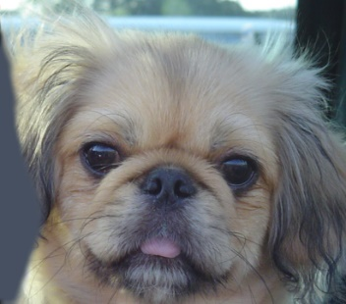 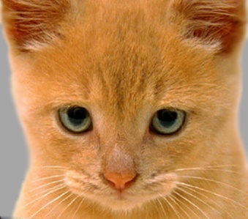

The low-pass (blurred) and high-pass versions of these images look like this:

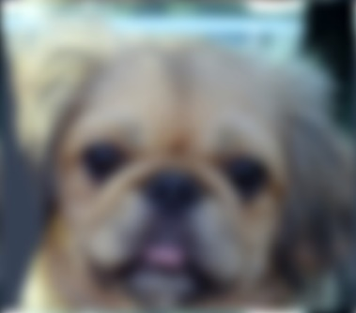 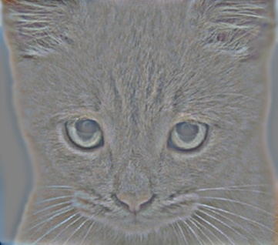

The high frequency image is actually zero-mean with negative values so it is visualized by adjusting the intensities as values between 0 and 1.

Adding the high and low frequencies together gives you the image at the top of this page. If you're having trouble seeing the multiple interpretations of the image, a useful way to visualize the effect is by progressively downsampling the hybrid image as is done below:

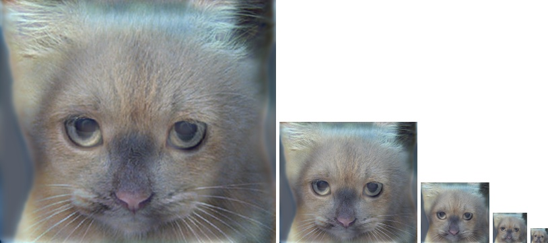

The starter code provides a function vis_hybrid_image in utils.py which can be used to save and display such visualizations.

**Potentially useful NumPy functions**: np.pad(), which does many kinds of image padding for you, np.clip(), which 'clips' out any values in an array outside of a specified range, np.sum(), and np.multiply(), which makes it efficient to do the convolution (dot product) between the filter and windows of the image.

**Forbidden functions** (you can use these for testing, but not in your final code): anything in OpenCV, and anything that takes care of the filtering operation for you. If it feels like you're sidestepping the work, then it's probably not allowed. Ask the TAs if you have any doubts.

**Rubric**

• +60 pts: Working implementation of image filtering in my_imfilter()

• +30 pts: Working hybrid image generation in create_hybrid_image()

• +10 pts: Writeup with several examples of hybrid images (5 combinations)

• +10 pts: Extra credit (up to ten points)

• -5*n pts: Lose 5 points for every time you do not follow the instructions for the hand in format

**Handing in**

This is very important as you will lose points if you do not follow instructions. Every time after the first that you do not follow instructions, you will lose 5 points. The folder you hand in must contain the following:

• code/ - directory containing all your code for this assignment

• results/ - directory containing your results (generated by the notebook)

**Do not use absolute paths** in your code (e.g. /user/George/CV/proj1). Your code will break if you use absolute paths and you will lose points because of it. Simply use relative paths as the starter code already does. Do not turn in the /data/ folder unless you have added new data. Hand in your project as a zip file through BlackBoard. You can create this zip file using python zip_submission.py.